**Task 1: Numbers and Variables**

**1. Create three variables in a single line and assign values to them in such a manner that each one of them belongs to a different data type.**

Ans:

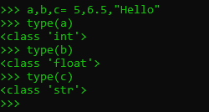

**2. Create a variable of type complex and swap it with another variable of type integer.**

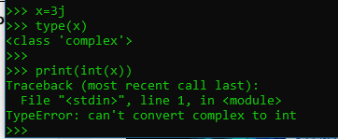

**3. Swap two numbers using a third variable and do the same task without using any third variable.**

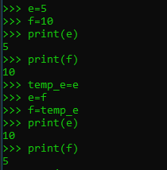

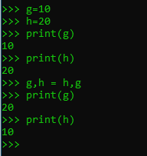

**4. Write a program that takes input from the user and prints it using both Python 2.x and Python 3.x**

**Version.#For Python 2.x**

m= eval(raw_input("enter your input:")

print(m)

**#For Python 3.x**

n= eval(input("enter your input: "))

print(n)

**5. Write a program to complete the task given below:**

**Ask users to enter any 2 numbers in between 1-10 , add the two numbers and keep the sum in**

**another variable called z. Add 30 to z and store the output in variable result and print result as the**

**final output.**

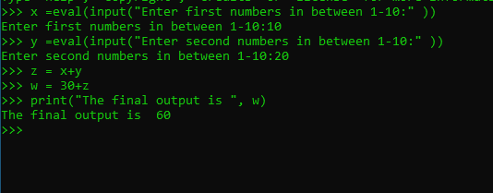

**6. Write a program to check the data type of the entered values.**

**HINT: Printed output should say - The data type of the input value is : int/float/string/etc**

